Matt Hammond
- I Left My Pennies in San Francisco

A number of assumptions must be made in order to answer this question with a reasonable degree of accuracy. First of all, I assume you're looking for the maximum number of (United States) pennies you can put on the bridge, because you can obviously choose to use any number of pennies within the range of 0 to this maximum. “Put on” is a pretty vague term, so who knows if these pennies need to remain stable by the force of gravity alone. Since I'm assuming we're really trying to go for broke here, and put the maximum amount o pennies on as possible, I'll assume these pennies can be stuck on with some adhesive. Now, if we're trying to maximize our penny to surface area ratio, we're obviously going to want to place each penny on its edge, and put down layers of these “penny rolls” rather than put them all out flat. Given a flat piece of bridge, it's not hard to figure out how many pennies/m² we can fit, just using the dimensions of the penny. The more tricky part would come in estimating the overall surface area of the bridge, including every surface that we could stick a penny to. This includes suspension cables and support beams. Even the beams are tricky, as most are likely not rectangular; they may be I-beams which would have substantially more surface area, and therefore penny-sticking area than a standard rectangular beam. We're just going to have to go with the information available and go from there.

From http://www.goldengatebridge.org/research/factsGGBDesign.php:

Total length of Bridge including approaches from abutment to abutment: 1.7 miles = 8,981 ft = 2,737 m
Width of Bridge: 90 ft = 27 m
There are two towers that support the bridge:
Height of tower above roadway: 500 ft = 152 m
Height of tower above water: 746 ft = 227 m
Tower base dimension (each leg): 33 x 54 ft = 10 x 16 m
Two main cables that support the bridge:
Diameter of one main cable including the exterior wrapping: 36 3/8 in. = .92 m
Length of one main cable: 7,650 ft = 2,332 m
The Golden Gate Bridge has 250 pairs of vertical suspender ropes that are spaced 50 feet apart across both sides of the Bridge. Each suspender rope is 2-11/16 inches in diameter. (0.0682625 meters)

Using this information, we're going to have to take some serious liberties regarding the extra surface area provided by the fact that the main span of the bridge is not a solid rectangular beam. I suppose we can start with treating it like it is, and introduce a correction factor later. The thickness of this central span was not immediately available, but estimating from photographs, we'll assume it is roughly 1/3 of the width, or ~9m.

Treating the main span like a rectangular beam, we have 27 m x 2,737 m x 9 m. So the surface area would be 2(27 x 2,737)+2(9 x 2,737) = 197064 m² (We obviously can't use the ends).

Now how many pennies can we fit on here? Well, a U.S. penny 1.55 mm thick and has a diameter of 19.05 mm. I assume that stacking pennies on their edges and forming rows of pennies doesn't count as “overlapping”, because viewed from above, they are not. This means a single row of pennies is 19.05 mm wide, and can extend to the end of the surface, and a single penny would take up .01905 m x .00155 m = ~.0000295 m².

The central rectangular beam would therefore accommodate about 6.67 x 10⁹ pennies.

I'm going to make the same rectangular beam assumptions for the two towers, simplifying them into rectangular beams. I also assume we can only attach pennies above the water. So for each tower we have: 10 m x 16 m x 227 m (this time we can use the top) = (10x16) + 2(10x227) + 2(16x227) = 11964 m² for each tower, so 23928 m² for both towers. Now for the number of pennies, we have 23928/ .0000295 = ~8.11x10⁸ pennies.

The cables are trickier. They're curved, so you could potentially fit more pennies on than the surface area of the cable would lead you to believe. We could totally figure it out for suresies with a little trigonometry, or just add the diameter of the penny to the diameter of the cable (half the penny's diameter per radius) to account for the largest parts of the pennies that would be bumping into each other when surrounding the cable, but we're already grossly oversimplifying the rest of the problem, so let's just use the surface area. For the main cables we have .92 m x π x 2,332 m = ~6740 m² per cable, or 13480 m² for both. Not accounting for radius of curvature of the cable, that's 4.57x10⁸ pennies.

Now the vertical support cables. We don't know the length of each one individually, but let's average the length as one hale the distance from the bridge to the top of the tower, which is 152 m, so 76 m. Using the same neglect to cable curvature as above: .0683 m x π x 76 = ~16.31 m² per cable, of which there are 250 pairs, so 16.31 x 500 = ~8153.69 m² and 2.76x10⁸ pennies.

To summarize:
Bridge Segment | Total Area for Segment Type | # of Pennies for Segment Type
Main Span | 197064 m² | 6.67 x 10⁹
Towers | 23928 m² | ~8.11x10⁸
Suspension Cables | 13480 m² | 4.57x10⁸
Vertical Support Cables | 8153.69 m² | 2.76x10⁸
Total | 242625.69 m² | 8.22x10⁹

So with our assumptions and simplifications we have 8.22x10⁹ pennies. If you account for the hollowness of the main beam, and all the nooks and crannies you could stick pennies to, I could foresee this number increasing drastically, at least doubling.

But do we really need to be more specific? We're already talking about over $82 million worth of pennies. Can't we think of something better to spend this money on? Education? Food and medicine for poverty-stricken countries? Four hundred and eleven million Wendy's spicy chicken nuggets? I mean give me a break, you can't drive on it anymore, and it'll look the same from a distance! That is if the bridge can even support the weight! Our conservative estimate constitutes over 20.5 million kg of pennies. That's over 20,000 tons, not including whatever adhesive we use... I'm no civil engineer, but if you really want to continue with this project, you should probably talk to someone in the know before you start converting all your cash to pennies. Otherwise you might have to choose between bringing it all back to a Coinstar and taking the 7% hit (don't worry, that's just $5.7 down the drain) or rolling pennies for the rest of your life.

- But, But... This One Has More MEGAPIXELS!

Assuming the 16:9 aspect ratio is width:height, three sizes that would work are: 192x108, 384x216, and 576x324.

- A Knight's Tale (If Chaucer used Python)

The minimum moves for a knight to cover a standard 8x8 chessboard is 63, because he can hit a new square each move. This is shown by invoking Schwenk's Theorem (http://en.wikipedia.org/wiki/Knight%27s_tour). To prove that the minimum number of moves is 63, all we have to do is find one tour that can be completed in 63 moves, because you obviously can't do it in any less, because you need at least one move per space (not including the starting space). The Warnsdorff heuristic can be used to find closed tours, and is what I used in my program to label tours. It's not guaranteed to work (although I found it worked about 95% of the time), but my program just tries again if it fails. My program is contained in KnightTour.py, and can be run from the command prompt. In case you don't want to take the time to run it, here's an example output:

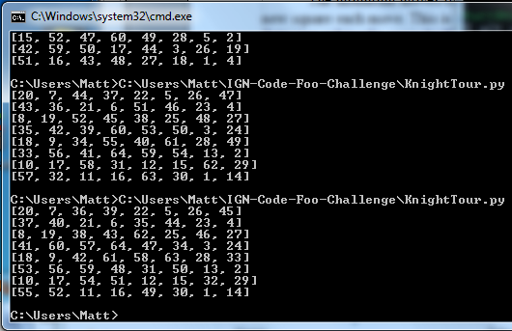
The numbers are the position numbers, not the move numbers, so they go to 64. In this program the knight always starts from the bottom right position, but can go through different tours each time, because the next move is occasionally chosen randomly if there is a tie in the value of the next available moves, based on the Warnsdorff heuristic.

Here's a graph displaying squares covered as a function of move number:

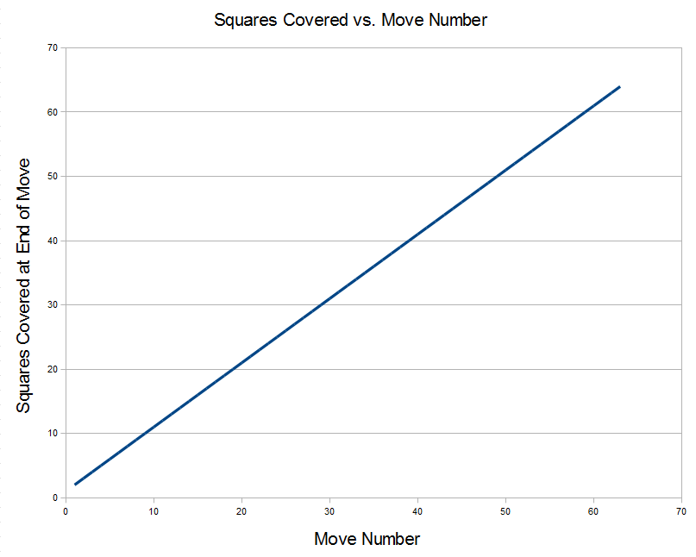

This is simply a straight line with slope = 1, as it's a closed tour and no squares are repeated. It may be hard to notice at first glance, but at move #1, two squares have been covered (since this is graphing the squares covered by the end of the labeled move, this is just a matter of preference). At move 63, all 64 squares have been covered.

- Nobody Likes a Beggar... But Pleeeaaaaase!

So looking at my resume, it may not be clear why I'm applying for this opportunity. I'm really more trained for physical sciences and (mostly non-software) engineering, so why would I try to get an internship doing mostly web programming? Probably because I LOOOOOVE video games and really value IGN's role in the industry! Let's face it, if I had been guaranteed a job in the video game industry from the start of college, I probably would have jumped on board right away. The entertainment industry is tough though, and it seemed more realistic to stick with something more concrete than to hedge my bets on an industry where talent goes unappreciated all the time. So I went the electrical engineering and computer science route, riding a thin line between setting myself up for the big bucks in industry and staying in touch with the technology I've always loved. Even throughout my undergraduate studies, I kept coming back to video games as an avenue of expressing my creativity in the field of electrical engineering. For my technical writing class, I did a 70 page mock business proposal on the efficacy of the new 120 GB slim PS3 that had just come out, and did my end of the year presentation on the evolution (hehe) of Pokemon as a franchise over the years, the role of Pokemon in the media and popular culture, and Pokemon ethical issues (seriously, are they eating the Magikarp or not?). For an embedded systems class my group used a linux-based platform to turn a bunch of Wiimotes into a music device featuring flutes, drums, and xylophones. The high point of a robotics class was a project that used a webcam and solenoids in a robot that played Rock Band drums on expert by itself. My A.I. project involved providing the brains for Pac-Man. My summer job after graduating basically involved turning N64 controllers into Wiimotes (wireless, inertial measurement). I guess the point I'm trying to make is that video games are, and have been since before I can remember, an integral part of my life, and working at any point in the industry has always seemed more of a dream than an actual career path. I think working at IGN would be an experience I'd always value and never forget.
So that's why I need you, but why do you need me? I've always been a hard worker and I've got the stats to back it up. I graduated high school with nothing but A's all four years, taking 5-6 AP/honors classes for the last two, and that was doing stuff I didn't even like! Then I went to Berkeley, pretty much undecided, but officially a mechanical engineering major, and switched to EECS because they told me it was the hardest major they had. Four years later I graduated with honors, and now I'm studying neuroengineering at UCLA mostly because it sounds so bad ass. More importantly than any of those accomplishments, though, I think IGN is a place where I can really let my creativity shine through. I don't get the impression that you're the type of people that stamp out ideas just because they seem a little different, and I think I could be a real asset to your team. Just to shine a little light on how interested I am and my priorities, let me just say that it's midnight right now, and instead of studying for a graduate systems neuroscience final I have in ten hours, I'm filling out this application just for a chance at an interview. So please take me into consideration, and good luck on your search for the best candidates.

